说明
MongoDB 是非常有名的 NOSQL 数据库.
下面是 Ubuntu 14.04 下 MongoDB 的安装, 同时还有针对 PHP 的配置 (driver 安装等), 此方法适用于 Homestead.

安装 MongoDB

1. 添加源
sudo apt-key adv --keyserver hkp://keyserver.ubuntu.com:80 --recv 7F0CEB10
echo 'deb http://downloads-distro.mongodb.org/repo/ubuntu-upstart dist 10gen' | sudo tee /etc/apt/sources.list.d/mongodb.list
sudo apt-get update

2. 开始安装
可以自定义安装的 Package 请见 这里.
sudo apt-get install -qq mongodb-org
安装完成检查是否开启:
$ ps -ef | grep mongo
mongodb 15683 1 1 03:00 ? 00:00:37 /usr/bin/mongod --config /etc/mongod.conf
检查版本:
$ mongo --version
MongoDB shell version: 2.6.6
$ mongo
> db.test.save( { test: 100 } )
> db.test.find()
{ "_id" : ObjectId("549253f4d91767276c02fc14"), "test" : 100 }

路径信息和默认参数说明:
- Sources: /usr/bin/
- Logs: /var/log/mongodb/mongod.log
- Data: /var/lib/mongodb/
- Default ip: 127.0.0.1
- Default port MongoDB is listening: 27017
以上信息都可以通过编辑 /etc/mongod.conf 进行修改.

开启/关闭
$ sudo service mongod start
$ sudo service mongod stop
$ sudo service mongod restart

安装 PHP Mongodb Driver

1. 安装 Driver
echo "no" > answers.txt
sudo pecl install mongo < answers.txt
rm answers.txt

2. 开启 PHP 扩展
echo 'extension=mongo.so' | sudo tee /etc/php5/mods-available/mongo.ini
sudo ln -s /etc/php5/mods-available/mongo.ini /etc/php5/fpm/conf.d/mongo.ini
sudo ln -s /etc/php5/mods-available/mongo.ini /etc/php5/cli/conf.d/mongo.ini
重启服务器
sudo service php5-fpm restart
验证是否安装成功
$ php -i | grep 'Mongo'
MongoDB Support => enabled

允许其他ip访问
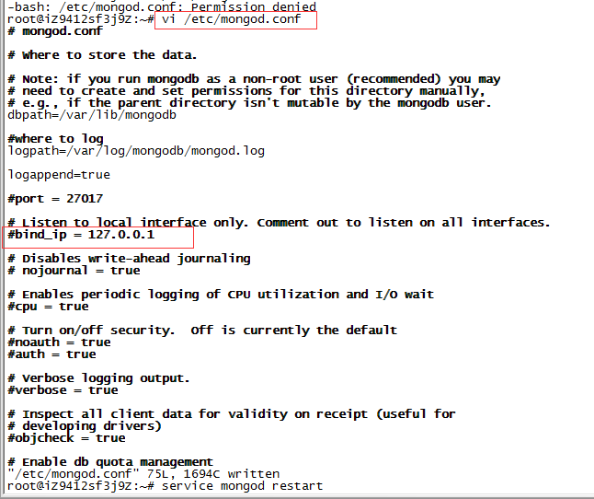

需要开启php扩展

Laravel下操作mongodb的插件
https://github.com/jenssegers/laravel-mongodb#eloquent

// $user=DB::table("test")->where('name', 'John')->first();
// dd($user);
/*查
$user = DB::connection('mongodb')->collection('test')->where('test','>', 0)->first();
echo $user['test'];*/
/*增
$re=DB::connection('mongodb')->collection('test')->insert(
['email' => 'john@example.com', 'votes' => 0]
);
echo $re;//1finish*/
/*增多
$re=DB::connection('mongodb')->collection('test')->insert([
['email' => 'taylor@example.com234', 'votes' => 0],
['email' => 'dayle@example.com222', 'votes' => 0]
]);
echo $re;//还是//1finish*/
/* update
$re=DB::connection('mongodb')->collection('test')->where('test', 100)->update(['votes' => 1,'test'=>99]);
echo $re; //1finish */
/* 简便的增加减少decrement
$re=DB::connection('mongodb')->collection('test')->where('test', 99)->increment('votes' , 5);
echo $re; */
/*删除
$re=DB::connection('mongodb')->collection('test')->where('test', 2)->delete();
echo $re; //1finish*/

